新成立獨立非牟利非政治研究組織香港黃金五十發表首份研究報告：現時香港增長機遇前所未見

香港，二Ｏ一一年九月一日：資深分析員林奮強先生最近成立了獨立非牟利非政治研究組織香港黃金五十，於本日發表首份研究報告「香港──黃金五年（2010-2014）盛衰關鍵」。

報告中不少令人驚訝的數字均顯示香港現時的增長機遇前所未見，香港黃金五十創辦人林奮強表示：「我們研究發現，香港現正經歷第二次高增長，服務業、教育、醫療保健以至各類型物業需求空前強烈，同時勞動人口卻隨著嬰兒潮老化及出生率降低而逐年萎縮至歷史新低。」

根據報告，本港實質經濟增長已連續六季超越十年平均值，財政盈餘高達港幣750億元（本地生產總值的4.3%），經濟將於黃金五年持續擴張。

報告預期黃金五年內香港機遇處處，並指出三種需求正高速增長，分別為香港人民幣存款、訪港旅客及醫療保健服務。香港人民幣存款兩年半內將從零躍升至二萬億，訪港旅客也將從二Ｏ一Ｏ年3500萬增加兩倍至二Ｏ一五年6500萬。

林奮強解釋：「資本和人才東流下香港現在必須致力保持競爭力。新加坡、深圳和上海均與我們力爭亞洲區內國際金融中心的位置，我們若不把握機會增建寫字樓、住宅、醫院和大學，機會將落入我們的競爭者手中。」

報告中引用第一太平戴維斯一項研究，預期中環呎租在二Ｏ一Ｏ至一二年間錄得兩倍升幅。呎租高企下租金成本將高於後勤職員薪金，以致需求流走至近年大量投資基建、教育及醫療保健服務等的新加坡。

勞工及土地供應短缺將導致香港錯失增長機遇，並進入高通漲時期。

香港若不盡快行動，種種負面後果將逐步浮現，因此香港黃金五十致力研究並發表報告，以喚起社會各界關注一系列與自身利益緊密相連的議題，進而展開廣泛討論和深入研究，引導香港朝正確的方向昂首闊步、勇往直前。

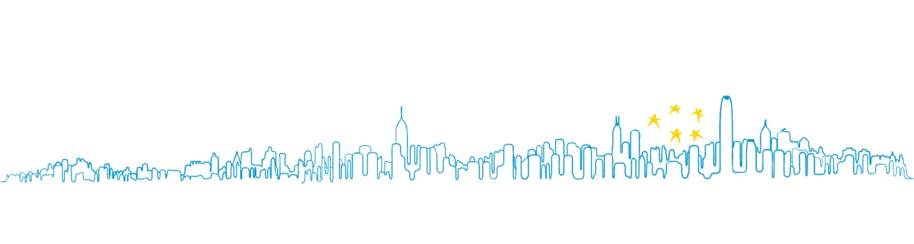
「我們這五年的抉擇將決定未來半個世紀的香港何去何從，我深信香港人會為自己的未來作出明智選擇。」林奮強如此總結。

研究報告可於香港黃金五十網頁www.hkgolden50.org下載。

關於香港黃金五十：
香港黃金五十於二Ｏ一一年六月由林奮強以個人資金成立之非牟利非政治獨立研究組織，由資深分析員林奮強先生帶領八位八十後成員，以客觀事實數據分析香港此刻的黃金機遇，並找出相應的制度瓶頸，發表研究報告。詳情請瀏覽www.hkgolden50.org。

傳媒查詢：
楊瑋婷小姐：sandy@hkgolden50.org
香樹輝先生：hsf@sirius.com.hk

New Independent Non-political Non-profit Research Organization HKGolden50 Publishes First Report Highlighting Unprecedented Growth Opportunities for Hong Kong

HONG KONG, 1 September 2011: A new independent, non-political, non-profit research organization, HKGolden50, founded by top researcher Mr. Franklin Lam, has published its first research report today on “Hong Kong’s Golden 5 Years and the Decline that may follow...?”

The research report reveals surprising figures that indicate unprecedented growth opportunities in Hong Kong during these five years. “Our research shows that Hong Kong is now experiencing a second growth spurt,” says Mr. Franklin Lam, founder of HKGolden50, “the demand for services, healthcare, education and all types of property has never been so strong; meanwhile our labour force will decline year after year as baby-boomers age and birth rate dips to an all-time low.”

According to the research report, this is the sixth consecutive quarter that the Hong Kong economy had expanded at a rate faster than its 10-year average. This growth has translated into a fiscal surplus of HK$ 75 billion in 2010/2011, equivalent to 4.3% of the GDP, and is set to continue to grow within these “Golden 5 Years.”

The research report expects many types of opportunities to take off in the Golden 5 Years and illustrates three sources of demand in particular that are growing tremendously in a J-shaped curve: Rmb deposits in Hong Kong, tourists and other visitors to Hong Kong, and healthcare services. Rmb deposits in Hong Kong are expected to leap from near-zero to two trillion in 2.5 years, whereas visitors to Hong Kong will almost double from 35 million in 2010 to 65 million in 2015.

“What Hong Kong does now is crucial in securing its competitiveness as capital and talents move eastward. Singapore, Shenzhen and Shanghai are all rival candidates to be the International Financial Centre in Asia. If we do not capture the opportunities in Hong Kong by building more offices, apartments, hospitals and universities, the opportunities will be shifted to our competitors,” Mr. Lam explains.
For instance, Savills Research predicts that the rental rate in Central will double between 2010 and 2012 on a per square foot basis. At such high rental rates, it may cost more in rents than salary to keep a support staff in Hong Kong someday. The most likely result would be a shift in demand to Singapore where the government has been actively investing in infrastructure, education and healthcare services, among other things.

Due to shortage in labour and land supply, Hong Kong runs the risk of not only missing out on the incredible growth opportunities today but entering a phase of high inflation.

Foreseeing the negative consequences if Hong Kong does not act quickly, HKGolden50 strives to conduct intensive research and publicise the results for the benefit of all Hong Kong stakeholders. The aim of the research is to create awareness and induce discussions among Hong Kong citizens to promote informed decision-making process for a better future.

“What we choose to do in the immediate 5 years will define the next 50,” Mr. Lam concludes, “I think Hong Kong will make the right decision.”

A copy of the research report can be downloaded from their website:
www.hkgolden50.org

About HKGolden50
HKGolden50 is a new non-political, non-profit, independent research organization that publishes research reports to illustrate through hard facts and figures the tremendous opportunities in Hong Kong and identify bottlenecks in the system. The research team consists of top researcher Mr. Franklin Lam and eight post-80’s members. The organization was founded in June 2011 and is privately funded by Mr. Franklin Lam. For more information about the organization and their research, please visit their website:
www.hkgolden50.org

For Media Enquiries:
Ms. Sandy Yeung, sandy@hkgolden50.org
Mr. Heung Shu Fai, hsf@sirius.com.hk

